Predicting Parabolic Motion

Purpose: Comparing measurements of physical quantities like time, velocity and displacement in parabolic motion with calculated values of the quantities using equations of motion, which are as follows:
- v = u + at
- s = ut + ½ at²
- v² – u² = 2as

Setup: Placing a Toy Gun at a height of 63 cm above the ground, and firing it at different angles while recording it in slow motion to take accurate measurements.

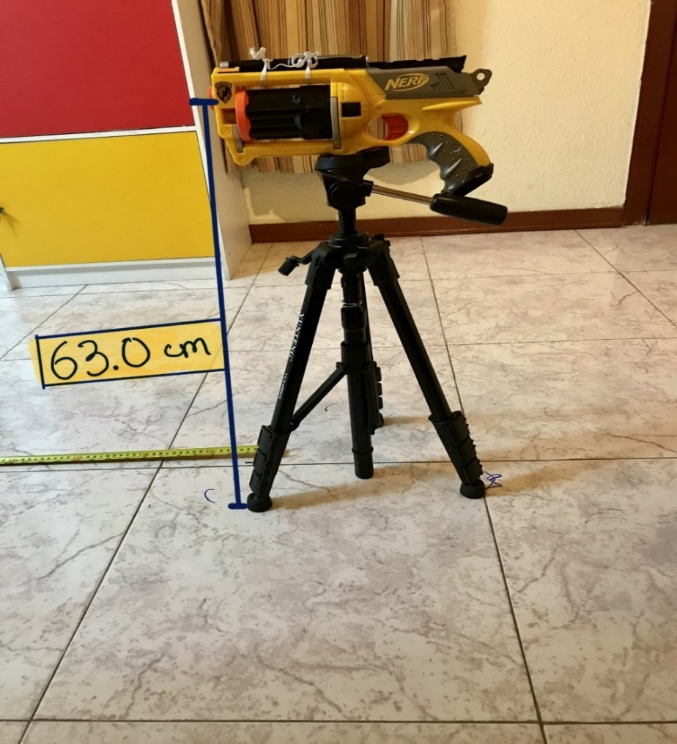
Experiment 1.
https://drive.google.com/drive/folders/1fkPkRp-MEeLigbzNdyFOraok5RssHDnz?usp=sharing
VIDEO OF EXPERIMENT.1

Inclination of Gun: 0º
Time of flight | Horizontal Displacement | Vertical Displacement
0.37 s | 3.82 m | -0.63 m

From 2nd equation of motion

S_{x} = u_{x}t + ½ a_{x}t²
= 0 - ½ *9.8ms⁻² * (0.37s) ² … (As the gun is shot at 0^{0,} initial vertical velocity = 0 m/s)
= - 0.67m

Calculated vertical displacement = -0.67m
Measured vertical displacement = - 0.63m

- margin of error = 6.35%

Calculating the initial velocity of the bullet:

As the gun is fired at 0º angle, it has no initial vertical velocity.
Therefore, its horizontal velocity is its initial velocity.

Horizontal Velocity = Horizontal Displacement / time of flight

= 3.82m/0.37s

= 10.324 m/s

We will now use this velocity to predict the motion of the bullet when it is shot at a different angle and compare it with the measurements taken.

Experiment 2.

https://drive.google.com/drive/folders/14u98L3Yg5IkLj1Ybx9uo4wUiOb2Y-VWZ?usp=sharing
VIDEO OF EXPERIMENT 2.

Inclination of Gun: 21.7º
^{Time of flight} | ^{horizontal displacement} | ^{vertical displacement} | ^{horizontal velocity}  ^{u cos(21.7)} | ^{vertical velocity}  ^{u sin(21.7)}
^{0.79s} | ^{7.6 m} | ^{-0.0401 m} | ^{10.324m/s* cos 21.7}  ^{= 9.592 m/s} | ^{10.324m/s *sin 21.7}  ^{= 3.817 m/s}

Horizontal displacement = Horizontal velocity * time
= u*cos (21) * t
= 9.592m/s * 0.79s
Calculated from Experiment 1.

= 7.578 m

Calculated Horizontal Displacement = 7.578 m

Measured Horizontal Displacement = 7.60 m

- Margin of error = 0.3%

Vertical displacement = u_{x}t + ½ a_{x}t² (from 2nd eq. of motion)
= u*sin (21.7) t – ½ gt²
= 3.817m/s * 0.79 s – ½ * 9.8 m/s^{2 *} (0.79s) ²
= - 0.04266 m

Calculated Vertical Displacement= -0.04266 m
Measured Vertical Displacement= -0.0401 m
- Margin of error= 6.4 %

Conclusion: the results obtained from using equations of motion are very close to the measured ones. The margin of error observed is due to:

- Air resistance and uneven air flow

- Light weight of bullet (air flow affecting the motion)

- Accuracy of measuring instruments

- Minor difference in firing force of toy gun during each trial

