Why Does Salt Have Such Interesting Properties on water?

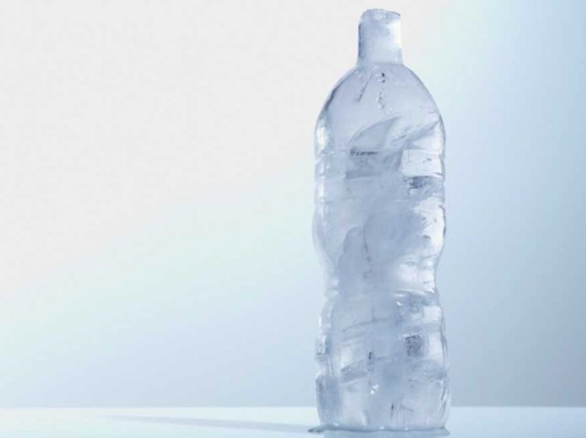
Water is a substance that is universally available, very interesting and has useful applications in life!
It is so important that the most common temperature scales, the Celsius scale, and the Fahrenheit scale, both chose the melting point of water as the beginning of the scale which is 0° C/F.
As we all know, water melts at 0° C and boils at 100° C. This is common knowledge and something everyone is aware of.
Whenever we speak of water, we instantly also think about ice, right? Snow perhaps, depending on where you live. Ice is essentially frozen water. It has interesting properties while not being chemically any different from the water we all know and love.

What is Freezing?
Freezing is the process in which a liquid changes to a solid. It occurs when a liquid cools to a point at which its particles no longer have enough energy to overcome the force of attraction between them.
The freezing point of a liquid or the melting point of a solid is the temperature at which the solid and liquid phases are in equilibrium.
The factors affecting this freezing point are the type of molecules that make the substance up. If the molecules have strong intermolecular forces, their freezing point is also relatively high and vice versa.
For most substances, the melting point and freezing point are the same. But exceptions always exist in nature.
Some substances like agar solidify over a range of temperatures and melt on an entirely different temperature.
Most liquids freeze by crystallization, including water. This is the formation of a crystalline solid from the liquid.
Crystallization has 2 steps to it:
- Nucleation - It is the step where the molecules gather into clusters and arrange in a uniform and orderly way, on the scale of nanometers to define the structure of a crystal.
- Crystal Growth – It is the step where all these nuclei that have reached a critical cluster size join and expand in all directions.
Pure water and other pure liquids usually form these crystals at temperatures lower than their melting point. Water is able to “super-cooled” to -40ºC at 1 ATM before it freezes!
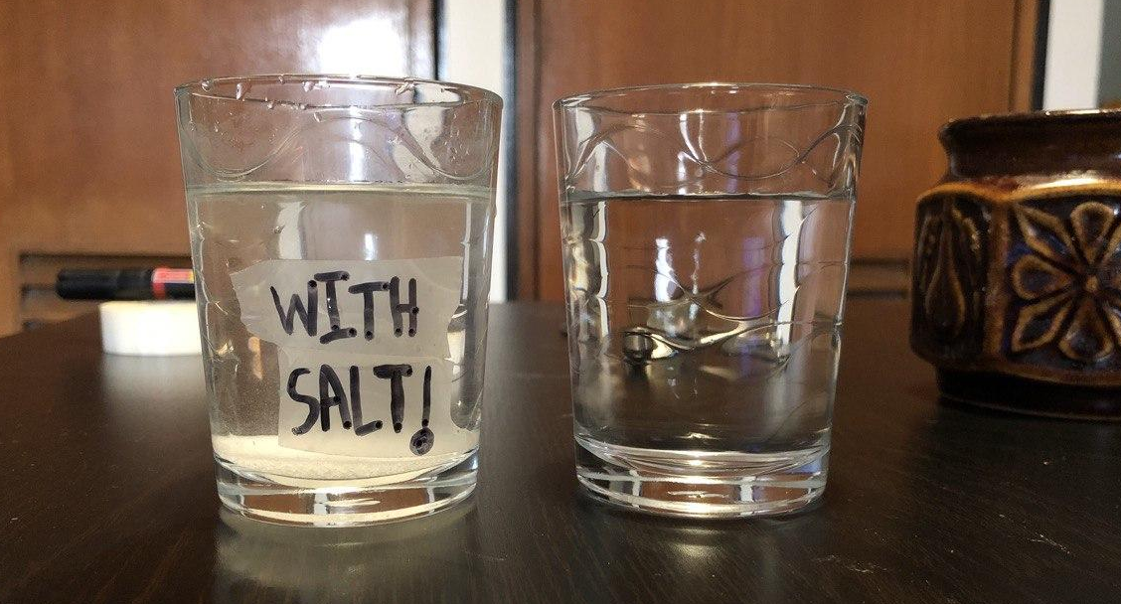
But, sometimes, ice which we know and love can also be quite a nuisance. For example, ice forming on undesirable locations like the pavement in winters which might cause accidents. How do you get rid of all that ice? Let’s look at an experiment I performed recently.
This was an image of the initial experiment taken at the beginning. After 1 hour and 50 minutes in the freezer, I noticed that the glass of water without salt was already frozen while the one with salt, had only formed a partially pasty liquid.
Wait, the water cup with salt didn’t freeze at the same time as the one without salt?
Lo-and-behold, did adding salt change the basic chemical properties of water??!! What is this magic?
As interesting as it is, the chemical properties of water haven’t changed. Both the added salt and water share the reason behind the decrease in the freezing point and the slight increase in the boiling point of water.
Water or more scientifically called H2O is a universal solvent. It dissolves a lot of things (solutes) and the common salt, NaCl, we used is one of them. Why and how is salt related to the decrease in the freezing point?
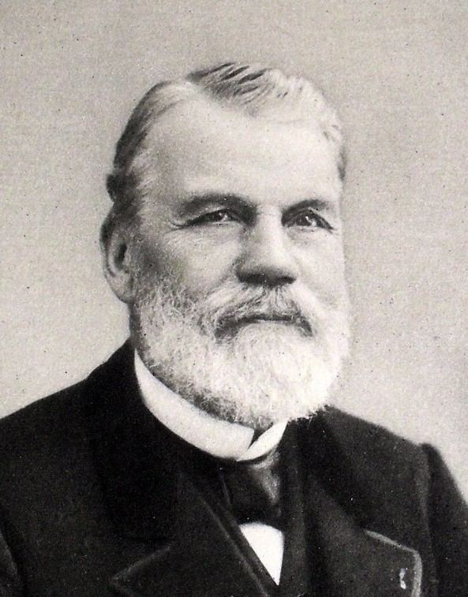
This observation was termed as “Freezing point depression” was discovered and proved by a French scientist named Raoult in 1882. We also call it Raoult’s law.
French Chemist, Raoult ->
“It stated that the depression in the freezing point of a solvent was proportional to the mass of substance dissolved divided by the substance’s molecular weight”
This means, the more salt(solute) we add to water(solvent), the lower the freezing point is going to be moved to. This also means that the freezing point depression isn’t being affected by temperature.
Another important thing to note would be the fact that the more ions the salt disassociates into, the lower will the new freezing point be.
For example, using CaCl₂ would result in lower freezing point as compared to NaCl as it disassociates into 3 ions.

How Does This Work?
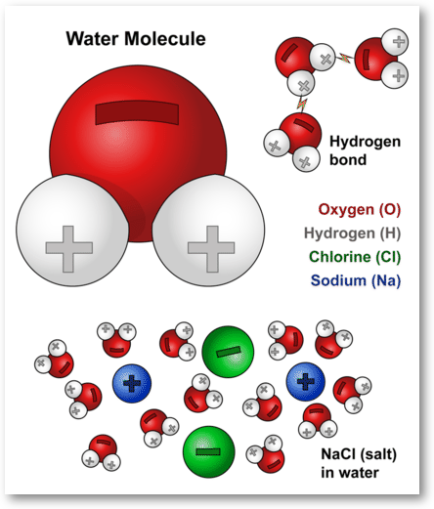
When NaCl is being put in water, the positively charged side of the water molecules is attracted to the negatively charged chloride ions, and the negatively charged side of the water molecules is getting attracted to the positively charged sodium ions. Here, water molecules pull the sodium and chloride ions apart, breaking the ionic bond which held them together. After it pulls apart the salt compounds, water molecules surround the sodium and chloride atoms. This dissolves the salt, resulting in a homogeneous solution.
These ions diffuse throughout the water and block the molecules of water from getting close enough and in the right orientation to organize into its solid-state, which is ice.
This doesn’t mean salt completely blocks water from becoming ice. Some ice still forms throughout the solution due to a lack of NaCl. This new ice tends to absorb energy from the surrounding water molecules to melt, but this would cause those water molecules to freeze.
Salt prevents this by stopping the surrounding water from freezing. Therefore, the new freezing point is essentially lower than the original freezing point of water, which was 0 degrees.
In a similar way, the boiling point of water is also increased as salt hinders the liquid water from changing to the gaseous state.

Can we calculate it for our experiment?
As per Raoult’s Law for Freezing point Depression, which is given by: -
ΔT = K_{F}·m
Where ΔT = the depression in freezing point
K_{F} = Freezing point depression constant of that solvent. In water, it is approximately 1.86ºC
m = molal concentration of solute
In our case, for the experiment I took approximately 17 grams of salt. Therefore, the molal concentration of solute is approximately 0.291 m.
Plugging in the value, we get ΔT = 1.86 x 0.291
= 0.54ºC
Since the salt we used splits into 2 ions, we will multiply the result by 2.
This means that the new freezing point is approximately 1.08ºC less than the original value.
Therefore, the salt solution we prepared has a freezing point of -1.08ºC! (approx.)

Curiosity is the mother of invention -
To sate my newfound curiosity, I switched up a few variables in the experiment. How does the mass of the substance affect the Freezing point of water? What will happen if I add a compound that doesn’t disassociate? What about tree bark, aka cellulose? What about add salt to some ice cubes? What effect would that have?
Below is a simple table with all my observations after performing those experiments.

Sample | Expected time (>, <, =  normal water) | Time taken
Plain Water | ~ | 1.83 hours
1 tbsp  salt solution | > water | 2.5 hours
2 tbsp  salt solution | > water | 5+ hours
Sugar solution | > water | 1.5-1.7 hours
Water with bark | equal to water | 1.83 - 2 hours

I got a very unique result from putting the cellulose in water and trying to freeze it. Unlike the rest of the results, the frozen ice had a bump on it despite making sure the container was completely clean.
This is the piece of bark
The bump on the surface of ice

Ice Cubes and Salt -
After the experiments with ice formation, I tried adding some salt to an ice cube and compare it with another ice cube without salt. As expected, the result was making the salty ice cube melt faster than the ice cube without salt.
Sample | Time taken to melt
Salty Ice Cube | 17 minutes 40 seconds
Plain Ice Cube | 20 minutes 10 seconds

The reason for the salty ice cube melting faster is that salt mixes with the thin layer of water on that ice cube. After that, it proceeds to anti-freeze like on plain water as explained 2 sections back.

Anti-freeze?
While we are on the topic of lowering freezing points, can we call the substances like Common salt as an anti-freeze? If not, then what is an actual anti-freeze?
Well, the answer is partially yes for common salt being an anti-freeze. Common salt acts as an anti-freeze only when the temperatures aren’t too low. And perhaps its effects aren’t good if we consider a situation of more extreme temperatures. So, what are some actual anti-freeze solutions?
An actual anti-freeze is a solution that has a lower freezing point than water and a higher boiling point than water. This will ensure that the substance remains liquid and can perform its duties sincerely.
Let’s take an example to understand this more clearly.
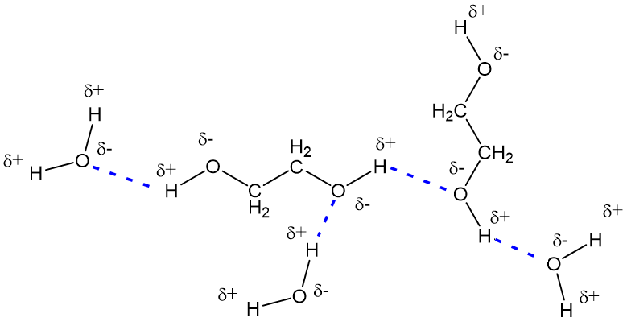
Ethylene Glycol or C₂H₄(OH)₂. On its own, it has a freezing point of -12ºC and a Boiling point of 197ºC. While this is already better than water, it can be further improved by ironically mixing it with water.
With a concentration of 70%, the solution has an even lower -55ºC as the freezing point, and it also increases the boiling point of the solution. This results in the formation of an effective coolant for cars and other machinery.
So why does this happen? Isn’t Ethylene Glycol a covalent compound? It doesn’t disassociate, but it affects the freezing point?
The fundamental reasoning for this is like how Common salt worked in the fact that it hinders the hydrogen bonding network in pure water. The way this works after that is a little different. Ethylene Glycol doesn’t disassociate.
First, ethylene glycol contains polar O-H groups, so it tends to polarize the electron pair in the O-H bond towards it. That, causes the oxygen to carry a partial negative charge and hydrogen a partial positive charge. Because opposite charges attract each other, this means that ethylene glycol molecules are attracted to each other, making it harder to pull them apart, and this, in turn, makes its boiling point higher than that of hydrocarbons of similar mass.
Water is also in a similar boat. It also has O-H groups that hydrogen bond with each other.
What does this have to do with the high boiling point and low freezing point?
This means that both ethylene glycol and water can also hydrogen bond with each other, just like their individual molecules, and make a solution with lower f.p and higher b.p. Glycerol, a covalent compound, also has similar effects when mixed with water.

Uses of Anti-freeze
Antifreeze and freezing point depression is a very exciting topic that catches your attention. A lot of work and research has been done on it since the 1800s. Why would people put in so much effort without obvious applications? So, let’s look at some practical applications:
- Melting accumulated snow along roadsides in winter -
This is perhaps the most common usage of salt as an antifreeze. About 20 million tons of salt is being used annually by the countries in the north to just get rid of the snow that has formed on roads.

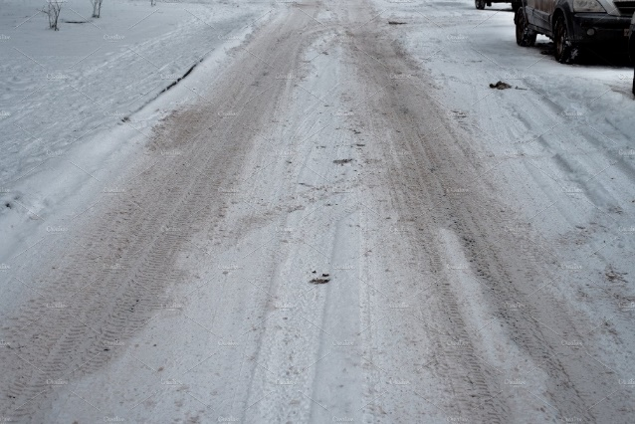

- Coolant for engines -
This is another common usage of anti-freezes. Every vehicle and machine that use engines usually make use of anti-freezes as a coolant for the engine.

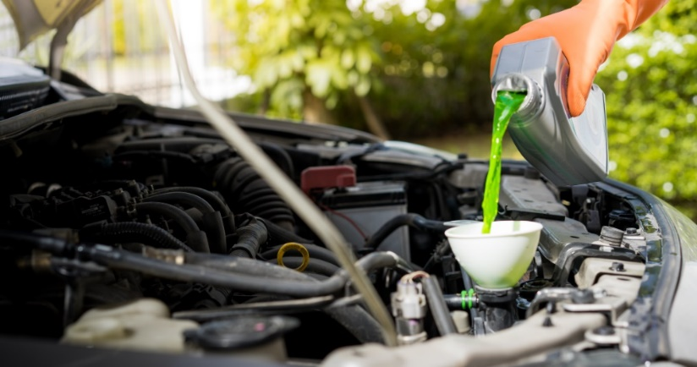

- Solar heaters and chillers –
Where the anti-freeze is used to prevent the outer enclosure from bursting due to the expansion of water when freezing.

- Liquid Cooled Computers –
Exactly like how it sounds. Some computers use liquid-based cooling, and since anti-freeze are incredible heat transfer systems, we use them.

- Air Conditioners –
As an efficient heat transfer system to cool the air.

Conclusion
Today, through this very activity, I was able to learn new things and understand the real logic behind why salt reduced the freezing point of water and how anti-freezes worked.
With that, I would like to conclude my explanation! Thank You for reading.

Interesting and unique physical observations during my experiment –
- 2 tbsp Salt solution –
This particular experiment took the longest of all the different setups that I tried. After waiting for 5+ hours, the water finally seemed mostly frozen. But when I touched it, I realized that the water had formed into so many tiny crystals in the sense that the ice was extremely powdered. There were innumerable clusters of ice and I believe it was because of the excess salt, which caused similar clusters of salty ice to clump together.

- 1 tsbp sugar solution –
Surprisingly, this resulted in a similar almost powdered texture, though less visible. The time it took to freeze was similar to pure water.

